**Ex No :4 Deploy IOT applications using platforms such as Blink app**

**Pulse Rate (BPM) Monitor using Arduino & Pulse Sensor**

**Aim**

To design a pulse rate monitoring system using an Arduino and a Pulse Sensor to measure the heart rate in Beats Per Minute (BPM) in Blink app

**Tools Required**

1. **Arduino Board** (Uno)
2. **Pulse Sensor** (e.g., Pulse Sensor Amped)
3. **Jumper Wires**
4. **OLED Display (Optional for visualization)**
5. **Resistors (if required)**
6. **USB Cable** (for programming and power supply)
7. **Arduino IDE** (for coding and uploading the program)

**Connection**

| **Pulse Sensor Pin** | **Arduino Pin** |
| --- | --- |
| VCC (Red) | 5V |
| GND (Black) | GND |
| Signal (Purple) | A0 (Analog Pin) |

(Optional: If using an OLED display, connect it to the appropriate I2C pins on the Arduino.)

**Pulse Sensor**

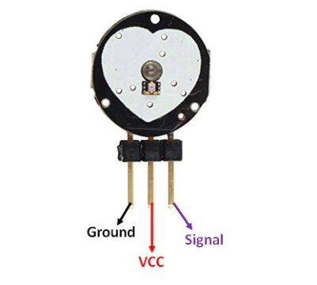

**Background Theory**

The Pulse Sensor works on the principle of Photoplethysmography (PPG), which is a non-invasive method for measuring changes in blood volume under the skin. The sensor essentially consists of two main components: a light-emitting diode (LED) that shines light into the skin and a photodetector that measures the amount of light that is reflected back

Connection Diagram

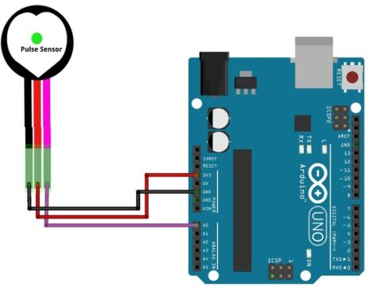

Download the PulseSensor Playground Library from the Arduino IDE (Go to Sketch -> Include Library -> Manage Libraries, then search for “PulseSensor Playground” and install it).

Coding

#define USE_ARDUINO_INTERRUPTS true

// Include necessary libraries

#include <PulseSensorPlayground.h>

// Constants

const int PULSE_SENSOR_PIN = 0;  // Analog PIN where the PulseSensor is connected

const int LED_PIN = 13;          // On-board LED PIN

const int THRESHOLD = 550;       // Threshold for detecting a heartbeat

// Create PulseSensorPlayground object

PulseSensorPlayground pulseSensor;

void setup()

{

  // Initialize Serial Monitor

  Serial.begin(9600);

  // Configure PulseSensor

  pulseSensor.analogInput(PULSE_SENSOR_PIN);

  pulseSensor.blinkOnPulse(LED_PIN);

  pulseSensor.setThreshold(THRESHOLD);

  // Check if PulseSensor is initialized

  if (pulseSensor.begin())

  {

    Serial.println("PulseSensor object created successfully!");

  }

}

void loop()

{

  // Get the current Beats Per Minute (BPM)

  int currentBPM = pulseSensor.getBeatsPerMinute();

  // Check if a heartbeat is detected

  if (pulseSensor.sawStartOfBeat())

  {

    Serial.println("♥ A HeartBeat Happened!");

    Serial.print("BPM: ");

    Serial.println(currentBPM);

  }

  // Add a small delay to reduce CPU usage

  delay(20);

}

Attach Blink app result

Blink app is assignment

Result

The system successfully detects and displays the pulse rate in **BPM**.